+CUI Handling Procedures

Purpose
The purpose is to establish procedures for handling and protecting documents that contains Controlled Unclassified Information (CUI) which are protected by laws, regulations and/ or government wide policies.

Scope
These procedures define requirements with identification, creation, sharing, marking, safeguard, storage, dissemination, disposition and destruction of documents containing CUI.
Note: The authoritative source for detailed information on CUI (e.g., categories, markings, policy and guidance, training) can be found on https://www.archives.gov/cui

Roles & Responsibilities
Role | Responsibility
Chief Executive Officer (CEO) | Compliancy oversight
Management Team | Procedure oversight
Employees | Procedures implemented

Procedures
  - CUI Creation and Marking
    - RED-INC doesn’t have the authority to create and deem information CUI without coordination and approval of Government sponsor.
    - In the event where a document provided by the customer meets the definition of the CUI, the customer will mark appropriately. RED-INC will handle and control all CUI information according to all required procedures.
    - All physical and digital documents and devices containing CUI must be marked in accordance with CUI Marking Handbook, from the Information Security Oversight Office, National Archives.
  - CUI Storage
    - Digital files containing CUI should be encrypted.
    - Digital files containing CUI will be stored on authorized systems and designated areas on RED-INC share drive.
    - Storage device(s) containing backup of CUI data will be marked, password protected, encrypted and physical stored in designated area.
    - Physical documents or devices containing CUI that aren’t being used, must be stored in a container indicating the contents contain CUI and kept in a room with an “Authorized Personnel Only” notification. Individuals not authorized to access those facilities are prohibited from entering them without an authorized escort.
  - CUI Usage
    - A document or device containing CUI will only be accessed by individuals who are authorized.
    - Documents containing CUI will only be accessed by individuals with a need-to-know.
    - All CUI documents and storage devices removed from an unauthorized area must be returned to an authorized area when it is not in use/transit.
    - All CUI outside of an unauthorized area will be in possession at all times by an authorized individual.
  - CUI Transport
    - Shipping/Mailing contents containing CUI should be mailed through USPS certified, first class, or express mail service. The contents should be put in a sealed package/envelope marked CUI then placed/wrapped in an unmarked sealed package/envelope for addressing.
    - Address packages that contain CUI to a specific recipient. Tracking of package should be conducted to ensure package is received and by the appropriate recipient.
    - Faxing of CUI must contain a transmittal document indicating CUI is attached or enclosed.
    - Emails containing CUI must be encrypted and marked appropriately.
    - Hand carrying of contents containing CUI throughout the facility or to another facility should have coversheet, stored in package/envelope and always in possession of individual.
  - CUI Disposal – Unreadable, Indecipherable and Irrecoverable
    - Hard copies containing CUI will be destroyed with an approved shredder. The shredder should be cross-cut producing particles 1mm x 5mm and have sign indicting that it is approved for the destruction of CUI.
    - Hard copies containing CUI will be placed in a marked shred container within the RED-INC facility. The authorized vendor will schedule pick-up of material to be shredded.
    - Digital media containing CUI must be destroyed according to the RED-INC Information Technology Equipment Disposal Procedures.
  - CUI Access Controls
    - Access to all CUI on RED-INC information systems will be managed under the rules of least access and least privilege. This entails granting access to project-specific CUI only to those individuals who’ve been assigned to work on a particular project. In addition, access shall be granted on a need-to-know basis.
    - Temporary access shall be granted to government customer approved, individuals and/or entities on a per document basis. In addition, the duration to which an individual or entity shall have access to a document or set of documents shall be determined when granting initial access. Upon reaching the ending of the access period, access privileges shall be reassessed.
    - Access to CUI on RED-INC information systems shall be revoked upon project reassignment, project completion, access duration limit being reached, and/or employment termination. An individual or entity whose access has been revoked shall be removed from all affiliated dissemination lists and the modification shall be noted by any related supervisors. The FSO shall also be informed of the access revocation.
  - CUI Incidents and Reporting
4.7.1 Any actual or suspected mishandling of CUI will be immediately reported to management.
4.7.2. Any unauthorized access of CUI should not be forwarded and immediately reported to management in order to direct what corrective actions should be taken.
  - CUI Recovery
    - Asset Consumption:
        - All consumed or about to be consumed physical and digital devices containing CUI shall have all CUI documents transferred to an approved CUI Storage Medium.
        - Approved CUI Storage Mediums can include limited access encrypted hard drives, restricted/limited access RED-INC shared drive and CUI Marked Areas.
    - Reassignment:
        - CUI media requiring reassignment shall be transferred to an employee’s Team Lead to act as a CUI custodian pending reassignment. All procedures detailed in Section 4.6 are be followed during reassignment.
        - In the event an employee’s Team Lead is not available, the CUI media is to then be transferred to management.
        - The CUI media shall be reassigned to the next applicable individual on the affiliated project. All procedures detailed in Section 4.6 are followed during reassignment.
        - If no such individual can be identified, then the CUI media is to remain in authorized location and management notified.
    - Employee Termination:
        - When an individual’s employment is terminated, it shall be the duties of the individual and his or her direct supervisor to turn over any and all CUI documents and/or media. The supervisor will then ensure CUI documents and/or media will follow in Section 4.2. All procedures detailed in Section 4.6 are to be followed during reassignment.
    - CUI Transport and Disposal:
        - In the event Physical and Digital media containing CUI cannot be easily recovered due to asset consumption or other means, than the media must be destroyed in accordance with RED-INC IT Equipment Disposal Procedures.

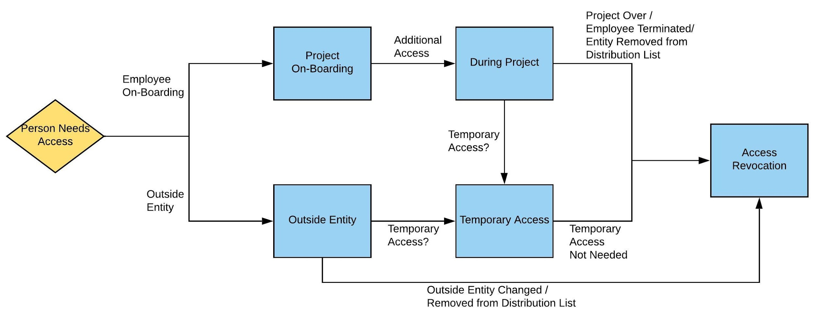
Figure 1: CUI Access Control Process Map
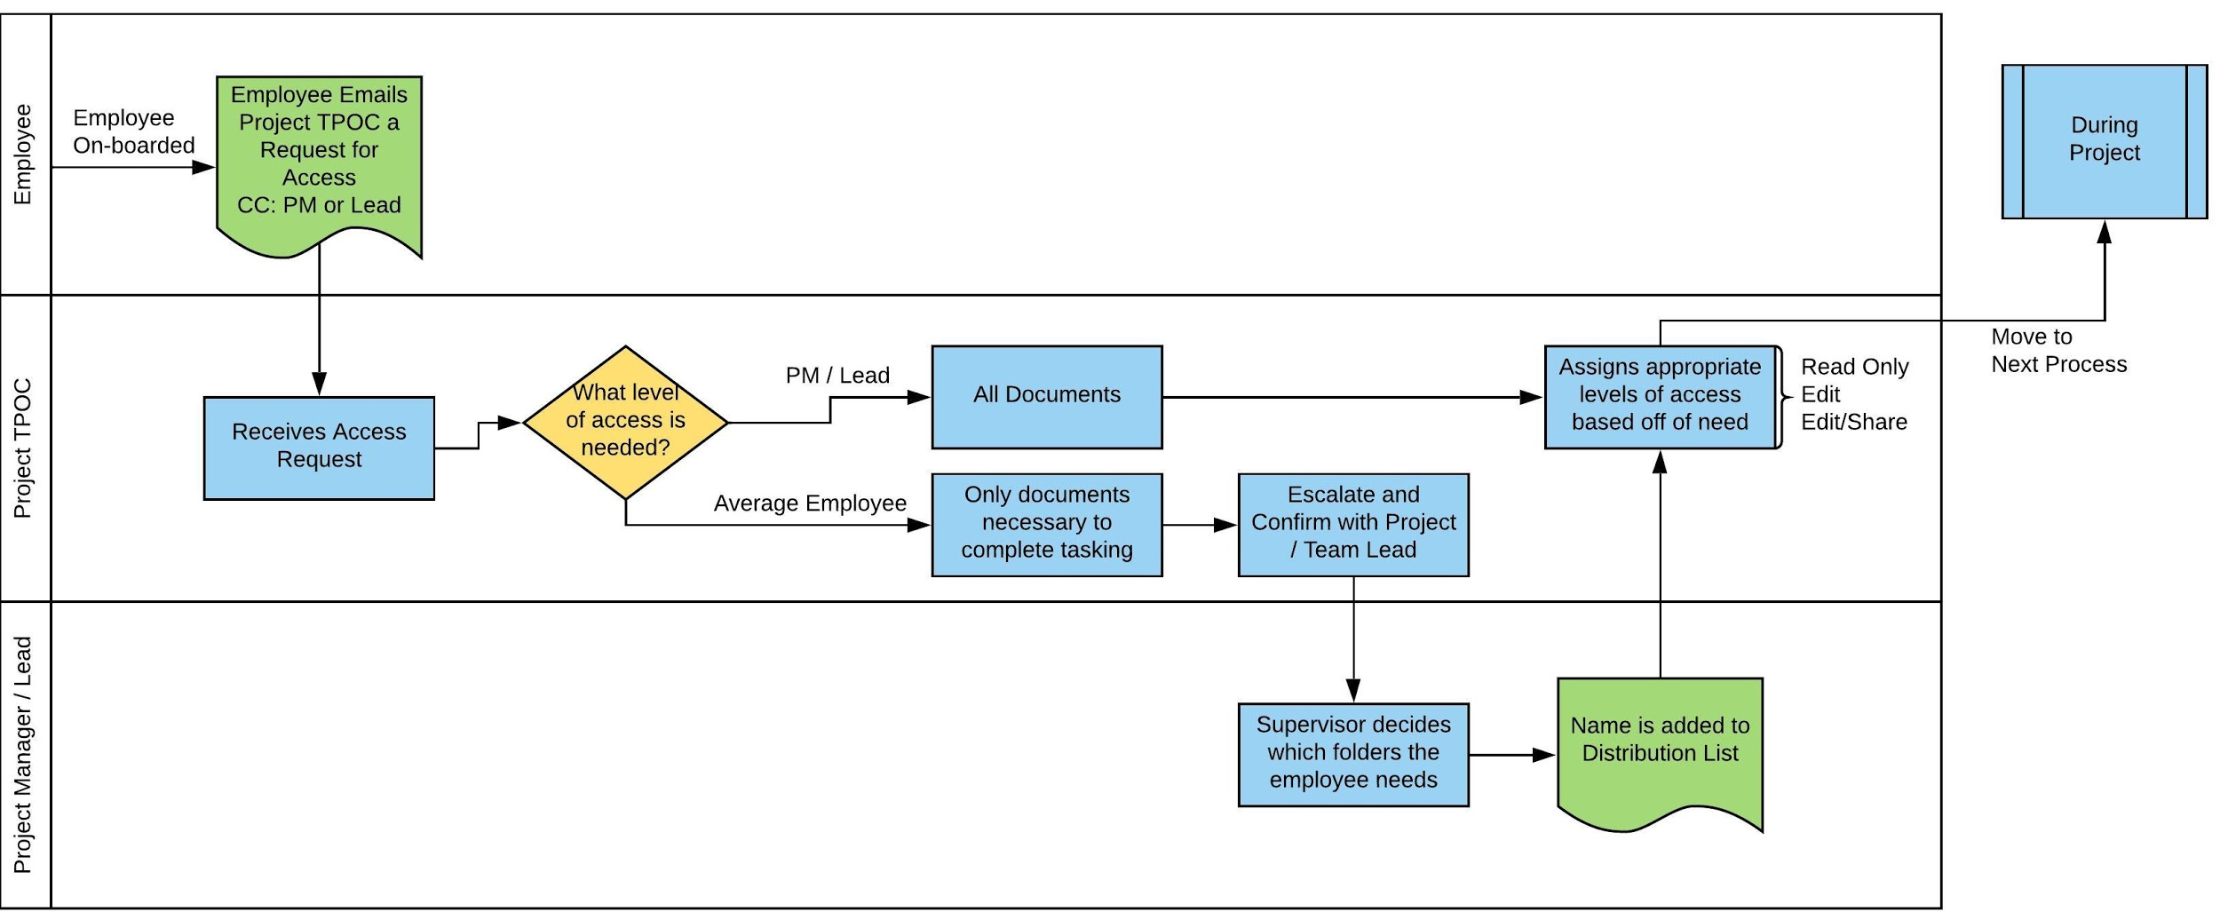
Figure 2: Project On-boarding Process Map
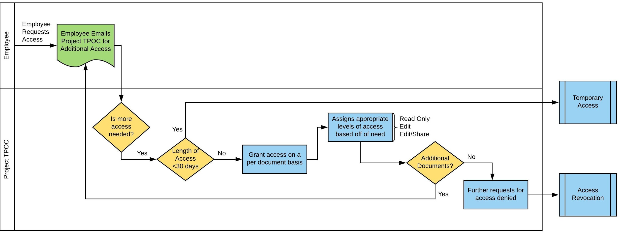
Figure 3: During Project Process Map
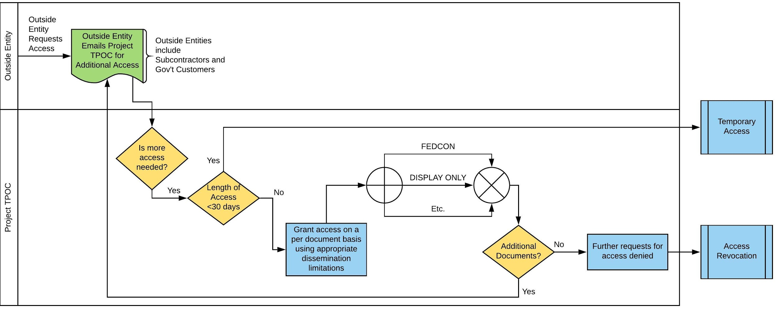
Figure 4: Outside Entity Process Map
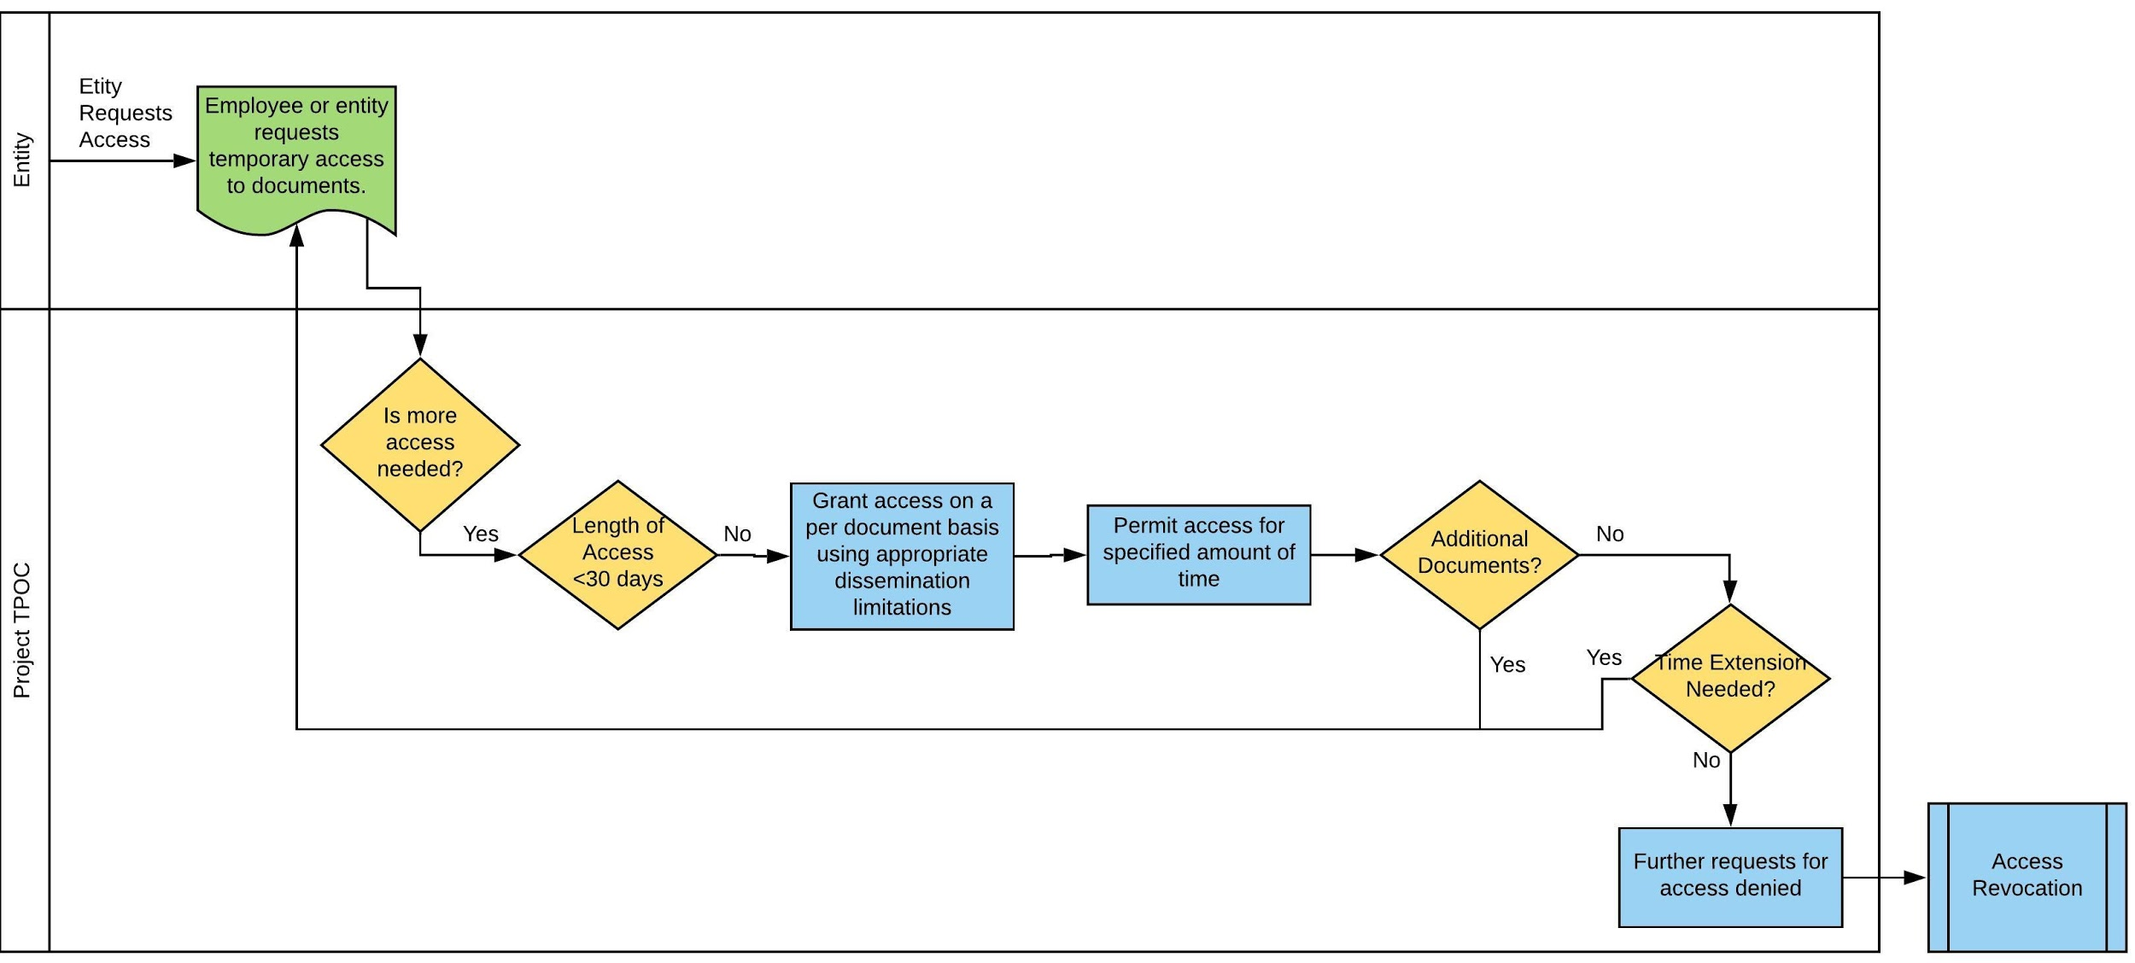
Figure 5: Temporary Access Process Map
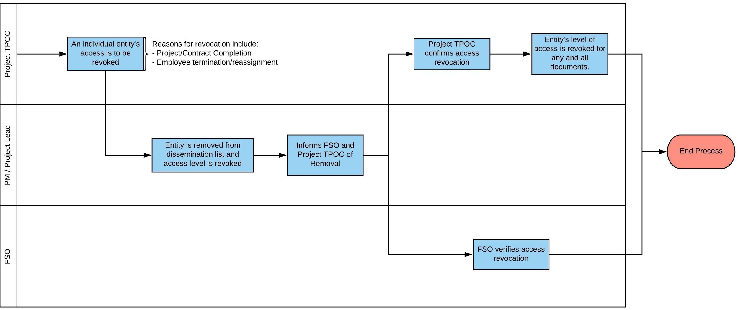
Figure 6: Access Revocation Process Map

Revision History
Date of Change | Responsible | Summary of Change
March 2021 | Rhonda Kirkpatrick | Created

